TERRAFORM 4
- Watch Terraform-04 video.
- Execute the script shown in the video.
- Main.tf
- Variable.tf
- Output.tf
- Add this script in variable
- variable "filename" {
- description = "Name of the file to be created"
- type = string
- default = "animals.txt"
- }

- variable "content" {
- description = "Content to be written inside the file"
- type = string
- default = <<EOF
- I love elephants
- I also love parrots
- EOF
- }

- variable "prefix" {
- description = "Prefix to use before the random name"
- type = string
- default = "MRS"
- }

- variable "length" {
- description = "Length of the random pet name"
- type = number
- default = 2
- }

- Main.tf

- 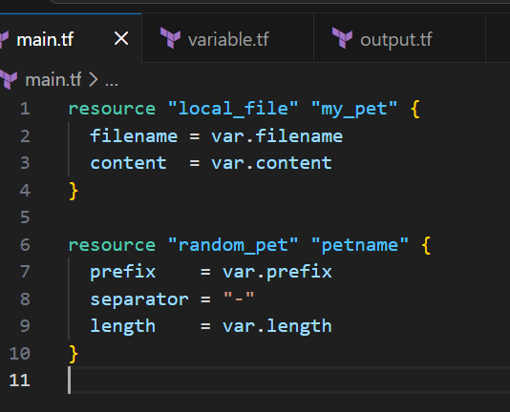
- Output file
- 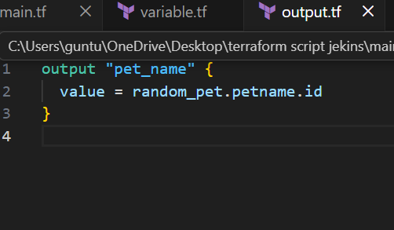
- Oipen terminal and terraform init
- And then terraform apply
- Animals.txt file will be created.
- 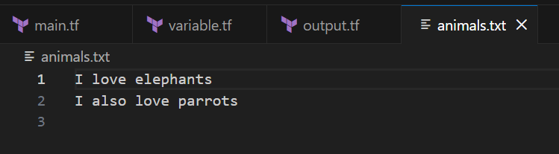

- Integrate Terraform in Jenkins using the Terraform plugin.
- • Go to Jenkins Dashboard → Manage Jenkins
- • Select Manage Plugins
- • Go to Available tab
- • Search for Terraform
- • Install:
- Terraform Plugin
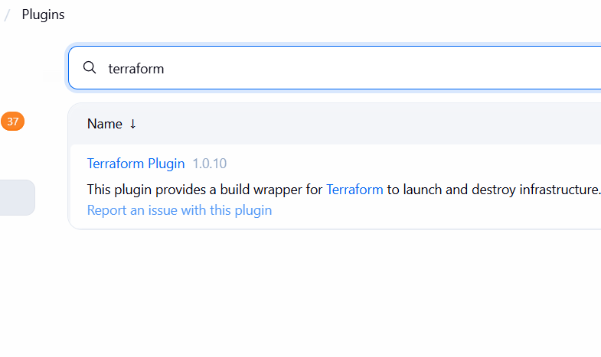
- 4 . Create a CI/CD pipeline for a Nodejs Application: https://github.com/betawins/Trading-UI.git
- Manage Jenkins
- Install pulgins
- Install nodejs from pulgins

- 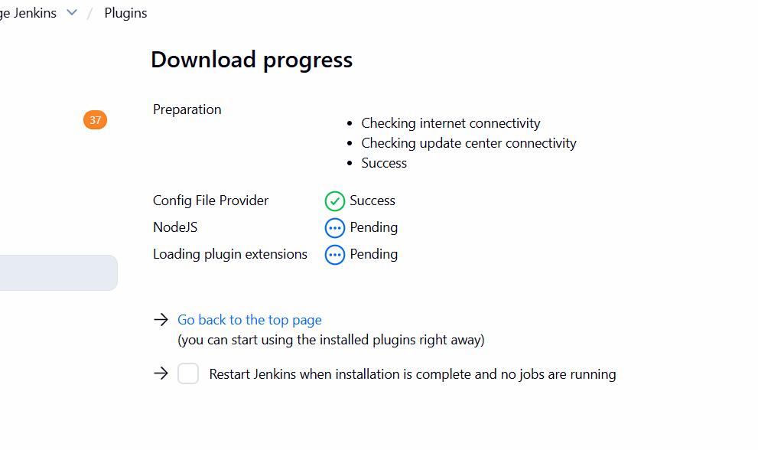
- Install nodejs
- 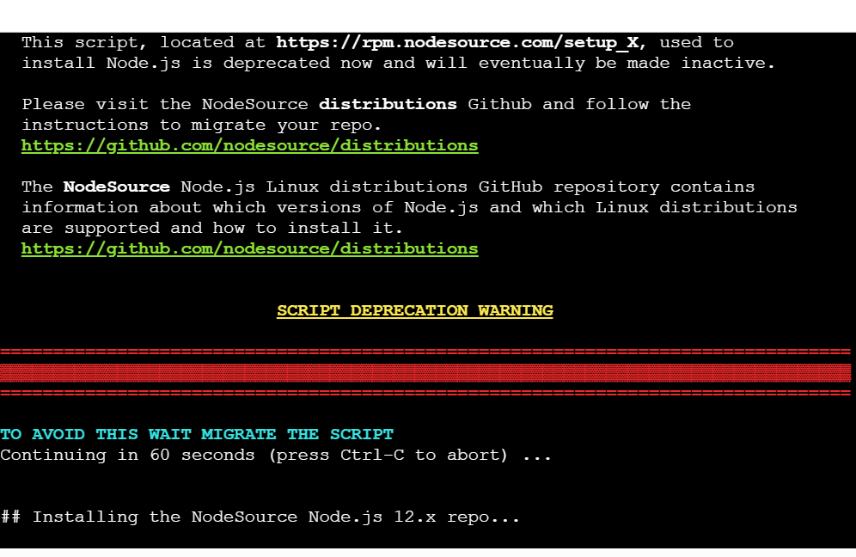
- Instal npm
- 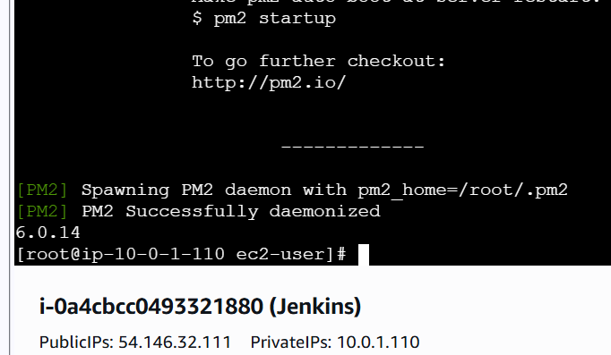
- Open port 3000 in inbound rules
- Fork the github repo and change thes jenkoins file
- Add this script
- pipeline {
- agent any

- stages {

- stage('Git checkout') {
- steps {
- git branch: 'master', url: 'https://github.com/betawins/Trading-UI.git'
- }
- }

- stage('Install Dependencies') {
- steps {
- sh '''
- echo "Installing dependencies..."
- npm install
- '''
- }
- }

- stage('Build UI') {
- steps {
- sh '''
- echo "Building Trading UI..."
- npm run build || true
- '''
- }
- }

- stage('Start App with PM2') {
- steps {
- sh '''
- pm2 delete Trading-UI || true
- pm2 start npm --name Trading-UI -- start
- pm2 save || true
- '''
- }
- }
- }

- post {
- success {
- echo "🎉 Trading UI Pipeline Completed Successfully!"
- }
- failure {
- echo "❌ Pipeline Failed — Check Logs"
- }
- }
- }
- Now creat e a pipeline in Jenkins
- Add git and scm
- 0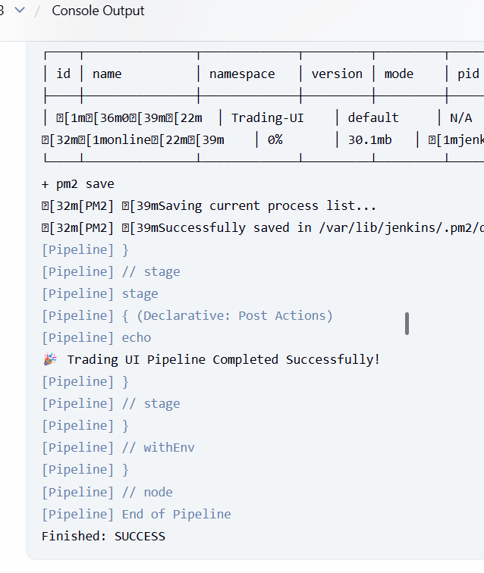

- 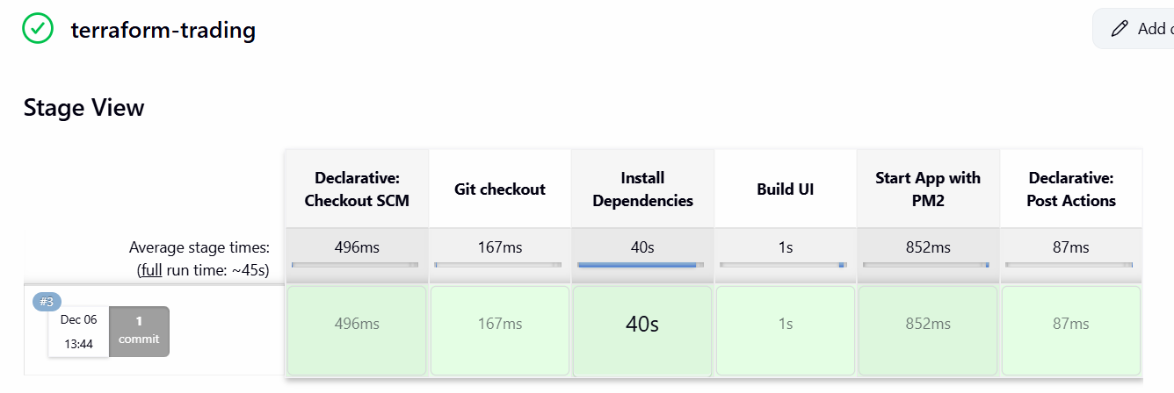
5 . Explain 10 Maven commands.
- 1. mvn -v (or mvn --version)
- ✔ What it does:
- Shows the installed Maven version, Java version, and environment details.
- ✔ Why used:
- To verify Maven installation.
- ✔ Example:
- mvn -v

- ✅ 2. mvn clean
- ✔ What it does:
- Deletes the target/ folder where Maven stores compiled files.
- ✔ Why used:
- To reset the project before building again (prevents old files from causing issues).
- ✔ Example:
- mvn clean

- ✅ 3. mvn compile
- ✔ What it does:
- Compiles Java source code into .class files inside target/classes.
- ✔ Why used:
- To check if your code has compilation errors.
- ✔ Example:
- mvn compile

- ✅ 4. mvn test
- ✔ What it does:
- Runs unit tests.
- ✔ Why used:
- To verify code functionality before deployment.
- ✔ Example:
- mvn test

- ✅ 5. mvn package
- ✔ What it does:
- Builds the application and creates an artifact:
- .jar (Java application)
- .war (Web application)
- Stored in target/.
- ✔ Why used:
- To generate deployable file for Tomcat/Nexus/Kubernetes.
- ✔ Example:
- mvn package

- ✅ 6. mvn install
- ✔ What it does:
- Creates the package and installs it in local Maven repository (~/.m2/).
- ✔ Why used:
- So other projects on your system can use this library.
- ✔ Example:
- mvn install

- ✅ 7. mvn deploy
- ✔ What it does:
- Builds the project and uploads the artifact to a remote repository like Nexus or Artifactory.
- ✔ Why used:
- To store artifacts for production deployments.
- ✔ Example:
- mvn deploy

- ✅ 8. mvn clean install
- ✔ What it does:
- Runs both:
- mvn clean
- mvn install
- ✔ Why used:
- This is the MOST COMMON pipeline command to build Java apps.
- ✔ Example:
- mvn clean install -DskipTests

- ✅ 9. mvn validate
- ✔ What it does:
- Checks if the project structure is correct and if the required files exist.
- ✔ Why used:
- To validate project before actual build starts.
- ✔ Example:
- mvn validate

- ✅ 10. mvn dependency:tree
- ✔ What it does:
- Shows all project dependencies in a tree structure.
- ✔ Why used:
- Used by developers to:
- Debug version conflicts
- Check which libraries are being included
- ✔ Example:
- mvn dependency:tree

- 🎁 Bonus Useful Commands
- 11. Skip tests
- mvn clean install -DskipTests
- 12. Run a Spring Boot application
- mvn spring-boot:run
- 13. Update dependencies
- mvn versions:display-dependency-updates

- 🎯 Summary Table
- Command | - Purpose | - Output
- mvn -v | - Check Maven version | - Version info
- mvn clean | - Remove target/ folder | - Clean build env
- mvn compile | - Compile source code | - .class files
- mvn test | - Run tests | - Test report
- mvn package | - Create JAR/WAR | - Artifact in target/
- mvn install | - Install to local repo | - Library in ~/.m2/
- mvn deploy | - Upload artifact to repo | - Deploy to Nexus
- mvn clean install | - Clean + install | - Most common build command
- mvn validate | - Validate project | - Checks structure
- mvn dependency:tree | - Show deps | - Debug conflicts

